Loadmaster Additions

Basic Web interface

This allows your customers to view their consignments using the internet in a reverse listing format for a specified period of days.

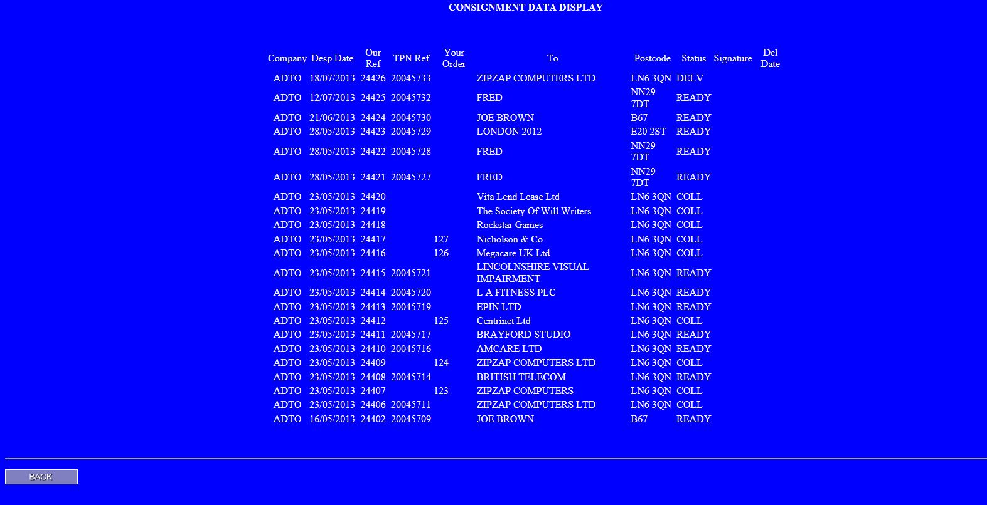

The column marked TPN Ref is optional.

The status codes are READY, COLL and DELV which mean ‘ready for collection’, ‘collected’ and delivered. If a signature has been obtained then this displays in the Signature column. The delivered date is shown in the Del Date column.

All customers can use this facility. You activate their use by completing the fields in their Loadmaster account setup which are marked as ‘web username’ and ‘web password’. Usernames should be unique.

The web server needs direct access to your data files to operate which means that you must set up a machine in your network to do this. It is quite simple under Windows 7 & 8. You go into Control Panel and Windows Options then turn ON the Internet Information Server. The computer will need the PHP language installing, this is obtainable free from www.php.com and loads everything needed without requiring any user intervention.

Your router should redirect inbound HTTP requests on Port 80 to this computer. It is suggested that you give this computer a fixed IP address internally on the router.

Your firewall needs to allow these inbound requests.

In addition the web server computer will need either a fixed IP address or a dynamic IP host such as dyndns so that it can be discovered externally. My example is online at http://zipzapzeus.dyndns.org/LM/getdata.php

The computer should be loaded with Loadmaster and able to access the data. You then go Control Panel, Administrative Tools and ODBC. Add a DSN connection called LM which uses HyperfileSQL (preloaded with Loadmaster).

Then by dropping 3 files into c:\inetpub\wwwroot and altering the contents of one file the system is up and running.

You can hyperlink the web server from your web site or supply the URL to your customers. When they log in they will see this -

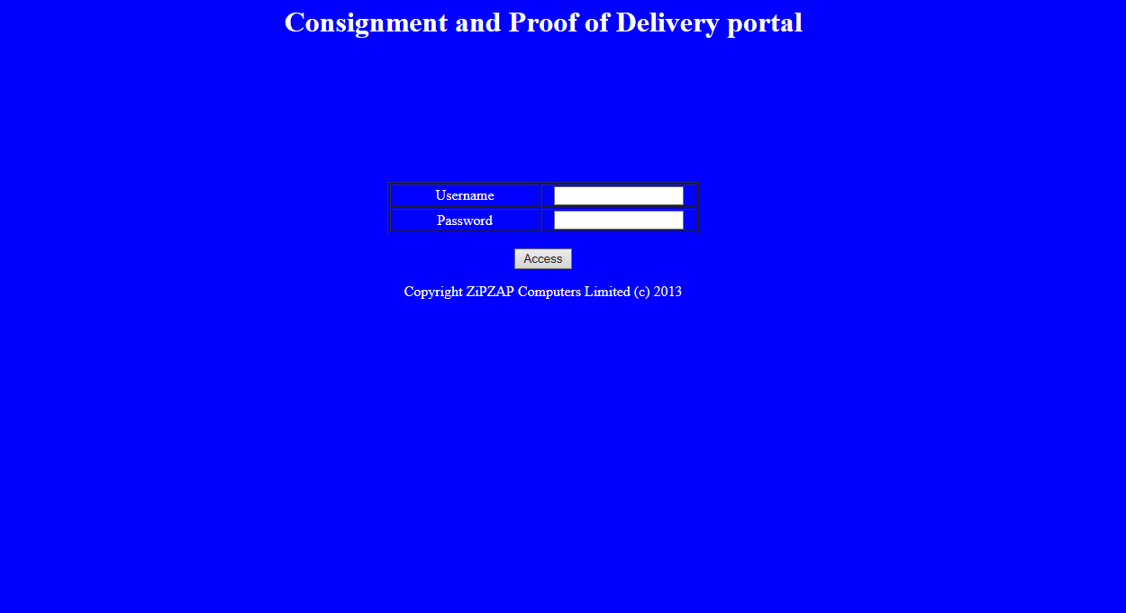

The information that they see is deliberately restricted.

